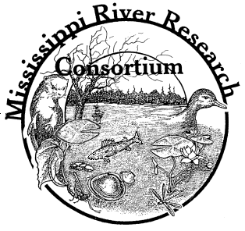
DATES: The 49th meeting of the Mississippi River Research Consortium will be held April 26-28, 2017. The meeting will begin at 6:30 pm Wednesday, April 26 with a welcome reception, keynote presentation, and evening social.

REGISTRATION:

Option 1: CLICK HERE TO REGISTER ONLINE. Upon completion of your registration, you will be directed to PayPal to make a secure online payment. (PREFFERED METHOD)

Option 2: Register onsite the day of the meeting and pay with cash, check or credit card payments through PayPal at the registration table; however, the late registration fee will apply.

Option 3: Register by mailing the paper registration found on page 2. (PLEASE ONLY USE THIS OPTION IF ABSOLUTELY NECESSARY)

If you have questions, contact MRRC Vice President, Patty Ries, (608) 781-6288, pries@usgs.gov.

LOCATION: The meeting will be held at the Radisson Hotel, 200 Harborview Plaza, La Crosse, Wisconsin, 54601. The Radisson Hotel is located in the heart of historic downtown La Crosse and overlooks the scenic Mississippi River. Featured in the Hotel are a restaurant, lounge, and indoor pool/whirlpool.

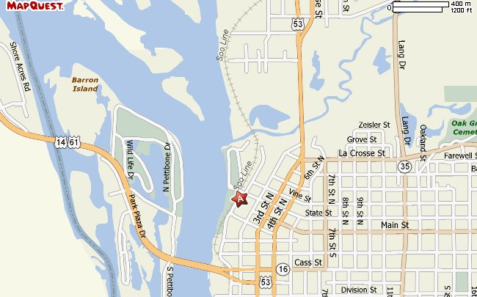

LODGING: A block of rooms has been reserved for the nights of April 25-27, 2017 at a state government rate of $82.00 for single occupancy or $112.00 for double occupancy per night plus taxes (13.5%) if reservation is made by March 25, 2017. The hotel telephone number is 608-784-6680. Please mention that you are with the Mississippi River Research Consortium.

AWARDS: Judging for the Best Paper and Best Poster Awards will take place for student presentations only. If you would be willing to serve as a judge, please indicate online during your Registration.
Registration Form
49th Annual Meeting
Mississippi River Research Consortium
Radisson Hotel
La Crosse, Wisconsin
April 26-28, 2017

NAME: ____________________________________________________________

AFFILIATION: __________________________________________________________

ADDRESS:______________________________________________________________

CITY: _______________________________________ ZIP: ______________________

PHONE:(Home/Work):__________________Email:_____________________________

Registration fee includes: 2017 dues and conference proceedings, Wednesday evening social and Thursday evening social and banquet, as well as Friday lunch.

Please indicate participation below (Y or N):
Wednesday evening social _____
Thursday evening banquet _____
Friday catered lunch _____

Please circle willingness to serve as a judge for student presentations: Y or N
If yes, are you available to judge Wednesday (evening), Thursday and Friday, please circle which days you are available to serve as a judge? Wednesday Thursday Friday ALL

Pre-Registration (by 7 April 2017): _____regular $105.00 _____student $75.00 _____retirees $45.00

Late Registration (after 7 April 2017): _____regular $120.00 ____student $90.00 ____retirees $60.00

Note: Hotel reservations must be made by 25 March 2017 to get the reduced room rate.

2017 Dues Only: ______$20.00 (members not attending, but wanting to receive the Proceedings)

Please make checks payable to the MRRC and mail to:
Mississippi River Research Consortium
c/o Neal Mundahl Department of Biology, Winona State University
P.O.Box 5838
Winona, Minnesota 55987

Note: You may also register on-site, the day of the meeting with cash, check or credit card payments through PayPal; however, the late registration fee will apply.

